**MIS 6308**

**Fall 2017**

**Assignment 4**

1. Consider the following program. (10 points)

Precondition: x is a non-negative integer and y is an integer.

(1) Read x,y

(2) Do case

(3) Case y = 0

(4) {Result = 1

(5) Print Result}

(6) Case y > 0

(7) {counter = 1

(8) Do while (counter <= y)

(9) Result = Result*x

(10) counter = counter + 1

(11) End Do

(12) Print Result}

(13) Case y < 0

(14) {counter = 1

(15) Repeat

(16) Result = Result*x

(17) counter = counter + 1

(18) Until (counter > -y)

(19) Result = 1/Result

(20) Print Result}

(21) End

1. Program graph for the above pseudo code is as follows: 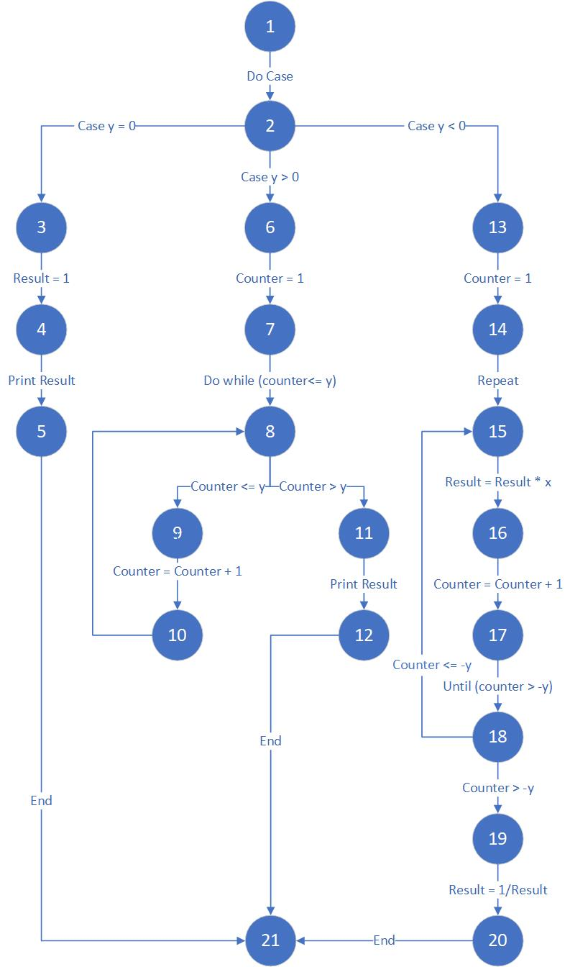
2. Test data to test the above program using statement coverage are as follows:
   1. X = 1, Y = 0
   2. X = 1, Y = 2
   3. X = 1, Y = -2
3. Test data to test the above program using branch coverage are as follows:
   1. X = 1, Y = 0
   2. X = 1, Y = 2
   3. X = 1, Y = -2
4. Test data to test the above program using path coverage are as follows:
   1. X = 1, Y = 0
   2. X = 1, Y = 2
   3. X = 1, Y = -2

and infinitely many more like

1. X = 1, Y = 1
2. X = 1, Y = -1
3. X = 1, Y = 3
4. X = 1, Y = -3
5. X = 1, Y = 4
6. X = 1, Y = -4
7. X = 1, Y = 4
8. X = 1, Y = 5
9. X = 1, Y = -5

2. Consider the following project.

Activity Duration (weeks) Precedence Relationship

1 2 -

2 1 -

3 3 1

4 2 2, 3

5 3 4

6 3 4

7 1 5, 6

8 2 5

9 1 6

10 1 7, 8

11 2 9, 10

1. PERT Chart for above project is as follows:

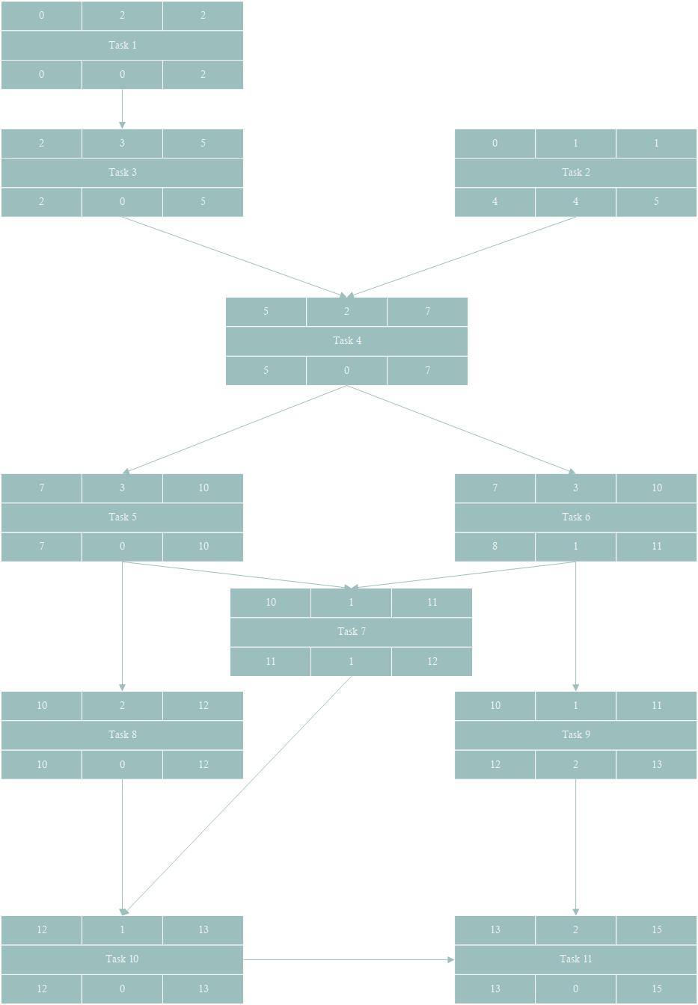

1. Slack for each activity is mentioned as below:
   1. Task 1: 0 weeks
   2. Task 2: 4 weeks
   3. Task 3: 0 weeks
   4. Task 4: 0 weeks
   5. Task 5: 0 weeks
   6. Task 6: 1 week
   7. Task 7: 1 week
   8. Task 8: 0 weeks
   9. Task 9: 2 weeks
   10. Task 10: 0 weeks
   11. Task 11: 0 weeks
2. Task 1, 3, 4, 5, 8, 10 and 11 are critical activities for this project.
3. 15 weeks at least are required to complete the project.